Sports Ball Master

User Manual Ver. 1.0

Table of Contents

1. Installation ______________________________________ pg. 2
   1. Installing Java Runtime Environment ____________ pg. 2
   2. Installing the program ________________________ pg. 2
   3. Starting the program _________________________ pg. 2
   4. Stopping the program ________________________ pg. 2
   5. First-time Users _____________________________ pg. 3
2. Step by Step Instructions ___________________________ pg. 4
   1. Main Menu ________________________________ pg. 4
   2. Create Account _____________________________ pg. 5
   3. Access Control _____________________________ pg. 6
      1. Athlete Accounts ______________________ pg. 6
         1. Home Tab ______________________ pg. 6
         2. Profile Tab ______________________ pg. 7
         3. Calendar Tab ____________________ pg. 8
         4. Team Tab _______________________ pg. 9
         5. Athlete Tab ______________________ pg. 10
         6. Sign Out Tab ____________________ pg. 11
      2. Manager Accounts _____________________ pg. 12
         1. Athlete Tab ______________________ pg. 12
      3. Fan Accounts _________________________ pg. 13
         1. Home Tab ______________________ pg. 13
         2. Profile Tab ______________________ pg. 14
         3. Team Tab _______________________ pg. 15
      4. Administration Screens __________________ pg. 16
         1. Create a Game __________________ pg. 16
         2. Edit a Game’s Score ______________ pg. 17
   4. Errors, Malfunctions, and Emergencies __________ pg. 18
3. File Structure ____________________________________ pg. 19
   1. Accounts File _______________________________ pg. 19
   2. Athletes File ________________________________ pg. 19
   3. Games File ________________________________ pg. 20
   4. Teams File _________________________________ pg. 20
      1. Specific Team Files _____________________ pg. 21

1. Installation

1.1 Installing Java Runtime Environment

In order to run Java programs, you will need to download and install the Java Runtime Environment, or JRE. You can download the JRE [here](https://www.oracle.com/technetwork/java/javase/downloads/jre8-downloads-2133155.html).

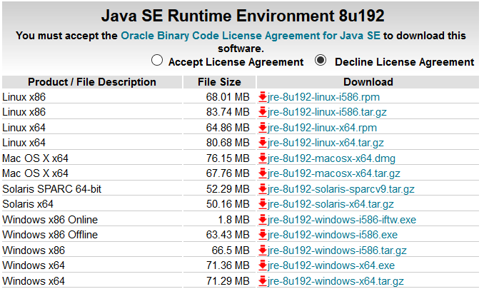

For ease of install on a Windows computer, click the download link for the Windows x86 Offline file with the “.exe” file extension.

Note: If you have a 64 bit computer, click the link to download the x64 file.

After download is complete, run the file and follow the on-screen instructions to install the JRE.

Installation instructions could be found [here](https://java.com/en/download/manual.jsp).

1.2 Installing the program

If you have not already downloaded the program, please open a web browser and go to the [Sports Ball Master](http://student.fgcu.edu/kduong3310/competition.html) webpage and click the download button to download the Sports Ball Master program. If already downloaded, you can skip to step 1.2 Starting the system.



You should end up with a file like the one to the left, defaultly found in your downloads folder unless you have specified otherwise.

System requirements:

* Windows XP or higher
* Internet Connectivity (only for downloading the program, this program do not need internet connectivity to run)

1.3 Starting the program



Double click the jar file, Sports Ball Master.jar.

This will start the program.

1.4 Stopping the program



At any time while the program is running, you can click ‘X’ at the top right of the window to close out of the program.

1.5 First Time Users

First time users will have an empty database and will have to create all the athlete and manager accounts in order to start using the program as intended.

2. Step by Step Instructions

2.1 Main Menu

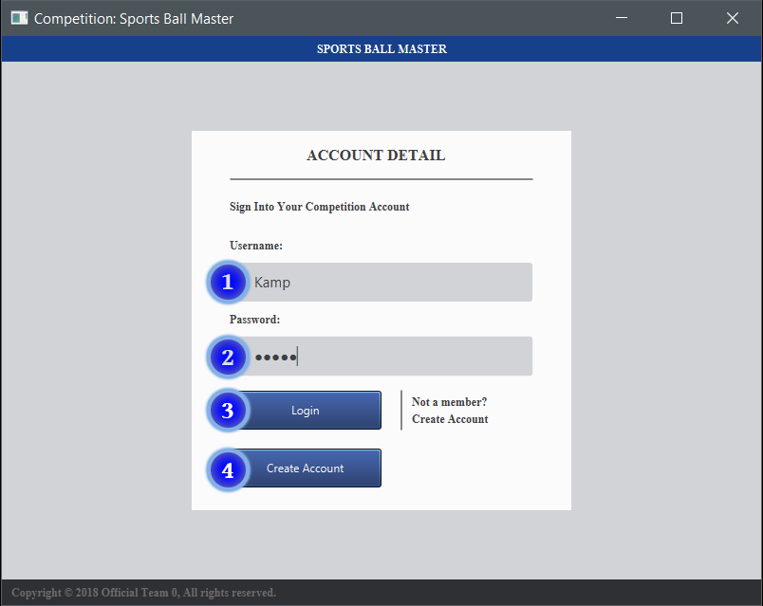

The Main Menu displays two input fields for the user to enter their login credentials to log into the system.

If the user does not have an account, the user can click the create account button to navigate to the Create Account screen and create a new account.

By default, the Administrator account’s login credentials are “admin” for both Username and Password.

|  |  |
| --- | --- |
| Screen Element | Description |
| 1. Username Text Field | This text box is used for entering user account’s username. |
| 2. Password Text Field | This text box is used for entering user account’s password. Entered text is displayed as dots for increased security. |
| 3. Login Button | This button will compare entered values in the Username Text Field and the Password Text Field with the saved accounts and will either log the user in if a match is found or display an error message is login credentials do not match any in the system. |
| 4. Create Account Button | This button will take the user to a separate screen to create a new account. |

2.2 Create Account

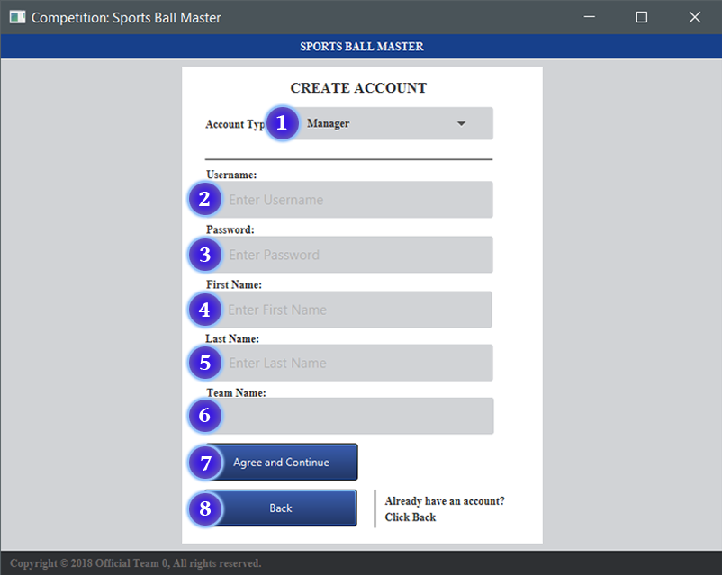

The Create Account screen allows the user to create 3 types of accounts: a fan, an athlete, or a manager account.

Creating a manager account unlocks the text field (6) so user can also give a name to the newly created team that the manager account will manage.

Note: None of the text input fields can contain a space. Alternatively, use underlines ‘_’ or hyphens ‘-’ to separate words.

|  |  |
| --- | --- |
| Screen Element | Description |
| 1. Account Type Choice Box | This combo box allows user to select the type of account to create. Choices are “Fan”, “Athlete”, and “Manager”. |
| 2. Username Input Field | Enter a unique username in this field. |
| 3. Password Input Field | Enter a password that is at least 6 characters long into this field. |
| 4. First Name Input Field | Enter a first name for account. |
| 5. Last Name Input Field | Enter a last name for account. |
| 6. Team Name Input Field | Enter a name for a newly created team. |
| 7. Confirm Button | Click to accept all input fields and create an account. |
| 8. Back Button | This button will navigate user back to the Main Menu screen. |

2.3 Access Control

2.3.1 Athlete Accounts

2.3.1.1 Home Tab

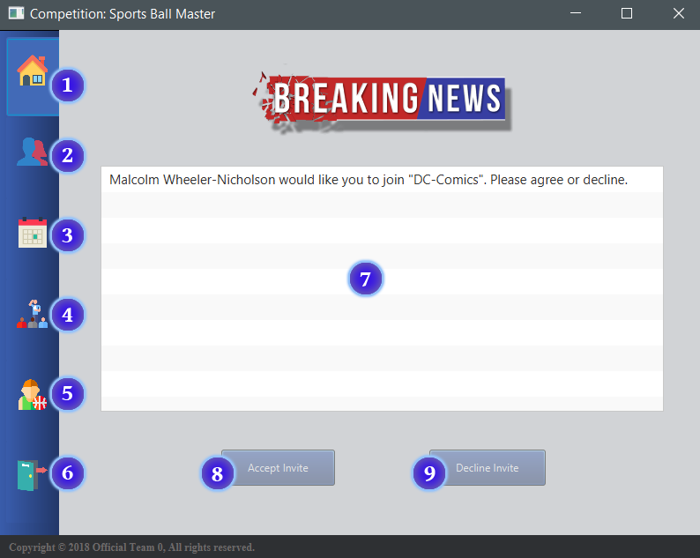

Once logged in, the user is taken to this screen, displaying the Home Tab by default.

Users are able to use the navigation bar on the left side of the screen to switch between each Tab.

The notification box and corresponding buttons is only available to Athlete and Manager account types. These options are hidden for Fan account types.

|  |  |
| --- | --- |
| Screen Element | Description |
| 1. Home Tab | The navigational tab to switch to the home tab. (Default tab) |
| 2. Profile Tab | The navigational tab to switch to the profile tab. |
| 3. Calendar Tab | The navigational tab to switch to the calendar tab. |
| 4. Team Tab | The navigational tab to switch to the team tab. |
| 5. Athlete Tab | The navigational tab to switch to the athlete tab. |
| 6. Sign Out Tab | The navigational tab to switch to the sign out tab. |
| 7. Notification Box | Notification box for displaying messages from team managers. |
| 8. Accept Button | Used to accept a manager’s invitation to join a team. |
| 9. Decline Button | Used to decline a manager’s invitation to join a team. |

2.3.1.2 Profile Tab

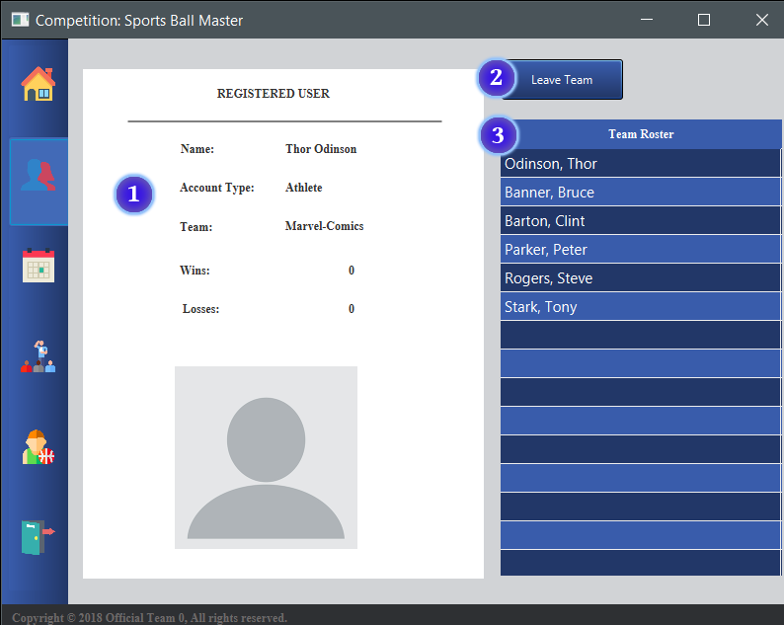

The Profile Tab displays the user’s account information.

The button at the top right allows users to leave the team they are on.

The leave button and roster table is also disabled if the user does not belong to a team.

Note: The Leave Team button has a different functionality for Fan accounts and is disabled for Manager accounts.

|  |  |
| --- | --- |
| Screen Element | Description |
| 1. User Account Information | This box displays the user’s name, account type, the team they are one, and their personal game wins and losses. |
| 2. Leave Team Button | Clicking this button will result in the user leaving their team and result in them belonging to “NoTeam”. |
| 3. Team Roster | This box displays the team roster of the team the user is on. |

2.3.1.3 Calendar Tab

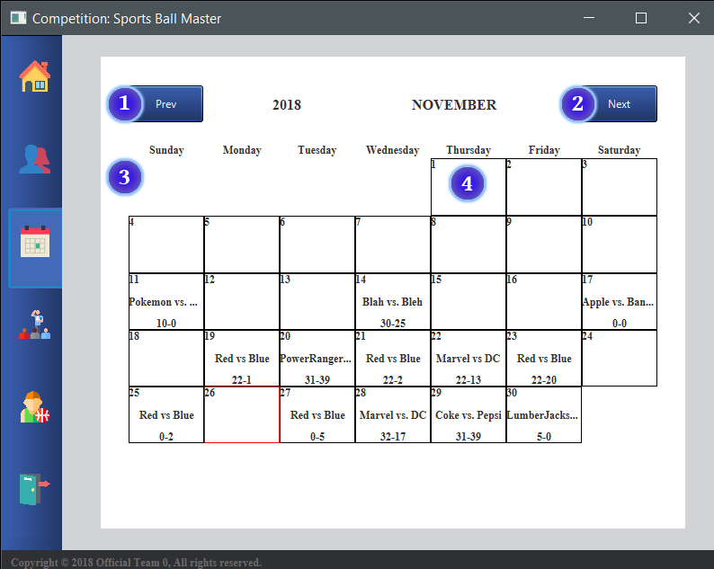

The Calendar Tab displays a calendar containing past, present, and future games and their corresponding scores.

The current day is outlined in red.

Keeping the mouse hovered over a day containing a game will display a pop-up with the game’s full details.

Note: This tab is the same for all users.

|  |  |
| --- | --- |
| Screen Element | Description |
| 1. Previous Month Button | This button loads the month previous to the current month displayed. |
| 2. Next Month Button | This button loads the month following the current month displayed. |
| 3. Calendar Grid | This grid displays the days of the month with Sunday as the start of the week. |
| 4. Calendar Boxes | Each individual box displays the day of the month and any game played that day and it’s score. |

2.3.1.4 Team Tab

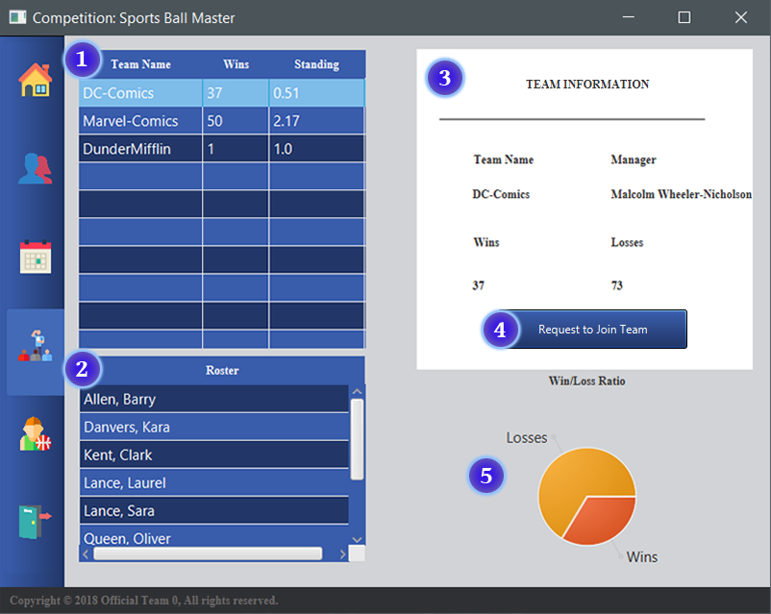

The Team Tab allows users to view information of each team in the league.

Each other element in this tab is dependent on the selected team and will update their information according to the team selected, allowing users to view more detailed information of the team.

Clicking the Request button will send a notification to the manager of the team notifying them that the athlete is interested in joining the team.

Note: The Request to Join Team button is different for Fan type users and disabled for Manager type users.

|  |  |
| --- | --- |
| Screen Element | Description |
| 1. Team Table | This table displays all the teams in the league, their total wins and their standings. |
| 2. Roster Table | This table will display the roster of the team selected in the Team table. |
| 3. Team Information Box | This box will display detailed information of the team selected in the Team table. Displayed are the selected team’s name, the manager’s name, total wins, and total losses. |
| 4. Request to Join Button | This button allows users to request to join the team selected in the Team table. |
| 5. Ratio Pie Chart | This Pie Chart will display the win loss ratio of the team selected in the Team table. |

2.3.1.5 Athlete Tab

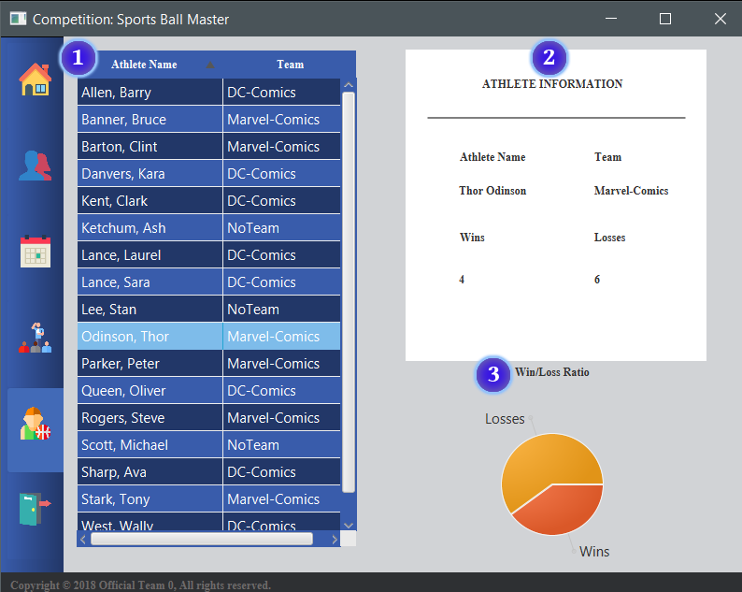

The Athlete Tab allows users to view information of each athlete in the league.

Each other element in this tab is dependent on the selected athlete and will update their information according to the athlete selected, allowing users to view more detailed information of the athlete.

|  |  |
| --- | --- |
| Screen Element | Description |
| 1. Athlete Table | This table displays all the athletes in the league and the teams they are on. |
| 2. Athlete Information Box | This box will display detailed information of the athlete selected in the Athlete table. Displayed are the selected athlete’s name, their team’s name, total wins and total losses. |
| 3. Ratio Pie Chart | This Pie Chart will display the personal win loss ratio of the athlete selected in the Athlete table. |

2.3.1.6 Sign Out Tab

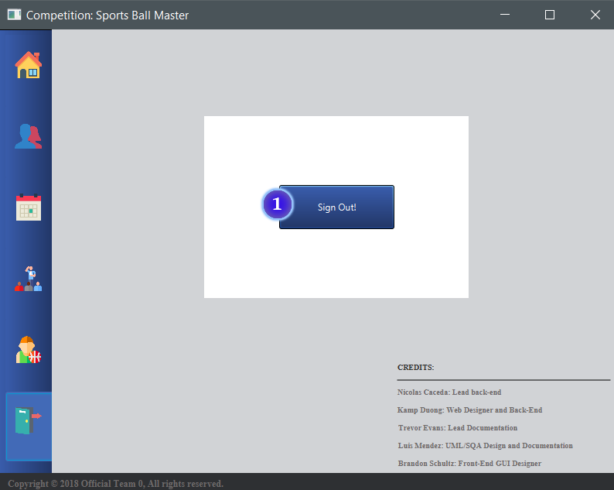

The Sign Out Tab is used to sign out of the current account.

The program credits are also viewable in the lower right hand side of the screen.

Note: This tab is the same for all users.

|  |  |
| --- | --- |
| Screen Element | Description |
| 1. Sign Out Button | Clicking this button will sign the current user out and bring the user back to the Main Menu. |

2.3.2 Manager Accounts

2.3.2.1 Athlete Tab

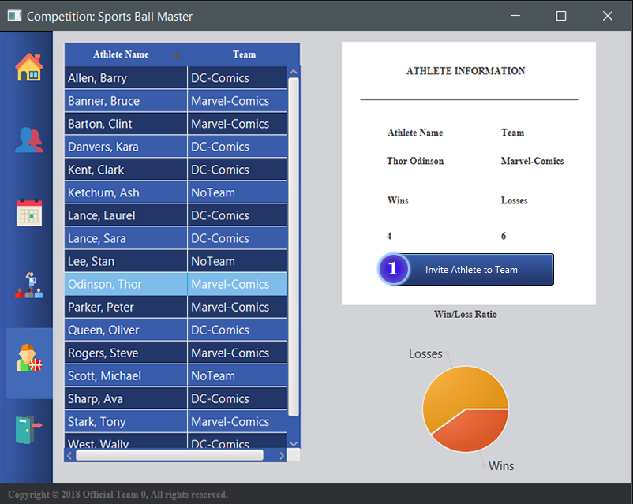

The Athlete Tab for users signed in as managers has a button used for inviting selected athletes to join the team the manager manages.

Clicking the button sends the selected athlete a notification to accept or decline the invitation to join the team.

This button is disabled for Fan and Athlete user accounts.

|  |  |
| --- | --- |
| Screen Element | Description |
| 1. Sign Out Button | This button allows users to invite selected Athletes to join the team. |

2.3.3 Fan Accounts

2.3.3.1 Home Tab

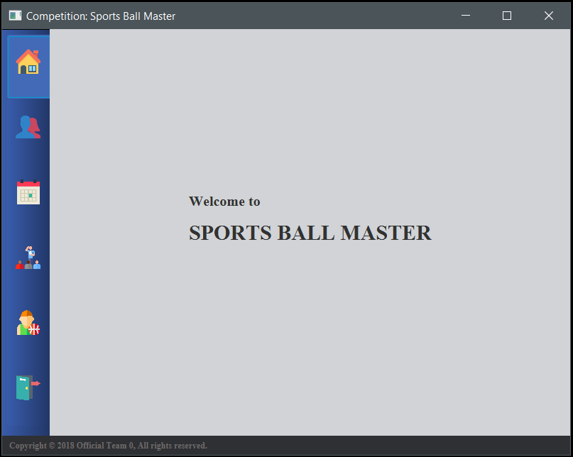

The Home Tab for users signed in as with fan accounts is the program’s Welcome screen.

This Welcome screen is replaced with a notification box for users signed in with an Athlete or Manager account.

2.3.3.2 Profile Tab

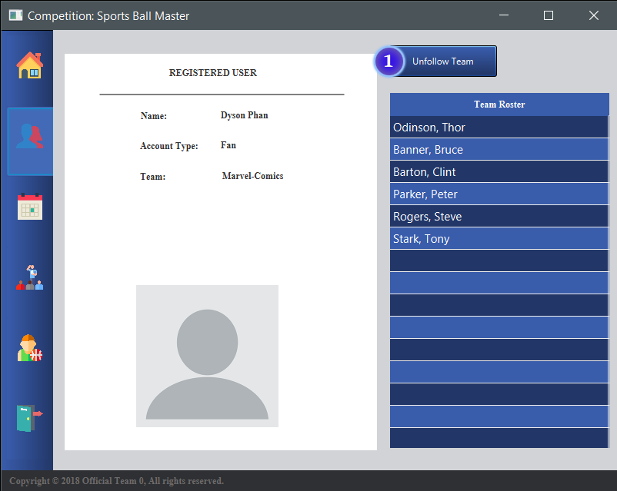

The Profile Tab for users signed in with fan accounts has a button that allows the user to unfollow the team they are following.

Followed teams will have the team’s information displayed in the profile tab so users would not have to search through the Team table in the Team tab for their team to view it’s information.

Note: This button is the Leave Team button for athletes.

|  |  |
| --- | --- |
| Screen Element | Description |
| 1. Unfollow Team | This button allows users unfollow the team they are follow, resulting in that user following “NoTeam”. |

2.3.3.3 Team Tab

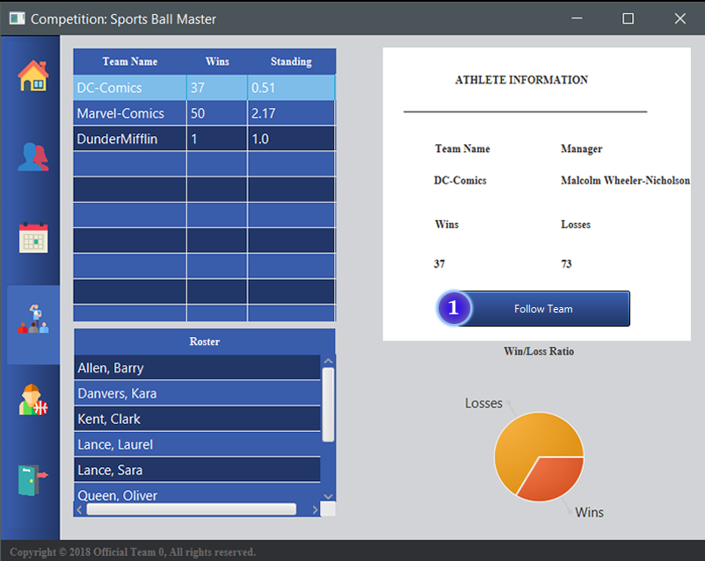

The Team Tab for users signed in with fan accounts has a button that allows users to follow the selected team.

Following a team will have the team’s information displayed in the profile tab so the user would not have to search through the Team table each time to view the team information.

Note: This button is the Request to Join Team button for athletes.

|  |  |
| --- | --- |
| Screen Element | Description |
| 1. Follow Team | This button allows users follow the team selected in the Team table. |

2.3.4 Administration Screens

2.3.4.1 Create a Game

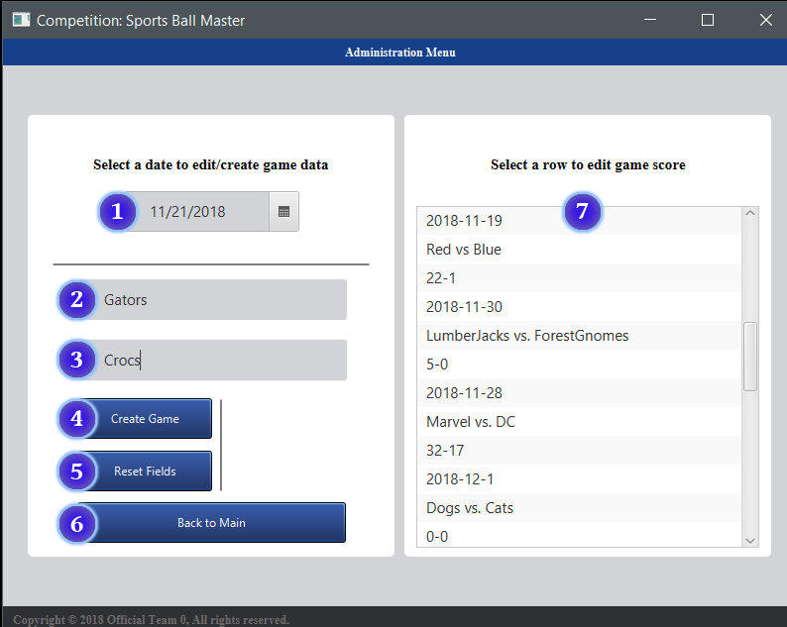

The Admin Screen is divided into two sides. The left window will contain input fields and buttons and the right window contains a list of games’ details.

At the top of the left sign, there is a date picker used to select a date to add a game on. Selecting a date will change the input fields and buttons to allow the user to create a game.

|  |  |
| --- | --- |
| Screen Element | Description |
| 1. Date Picker | This Date Picker is used to select a date to create a game on. |
| 2. Team 1 Input Field | Enter name of the first team to play on selected date. |
| 3. Team 2 Input Field | Enter name of the second team to play on selected date. |
| 4. Create Game Button | Confirm input fields and create a game with values in the fields. |
| 5. Reset Fields Button | Clears the input fields. |
| 6. Back to Main Button | Take user back to the Main Menu, signing out of the Administrator account. |
| 7. Games List | A list displaying all the games created in the system. |

2.3.4.2 Edit a Game’s Score

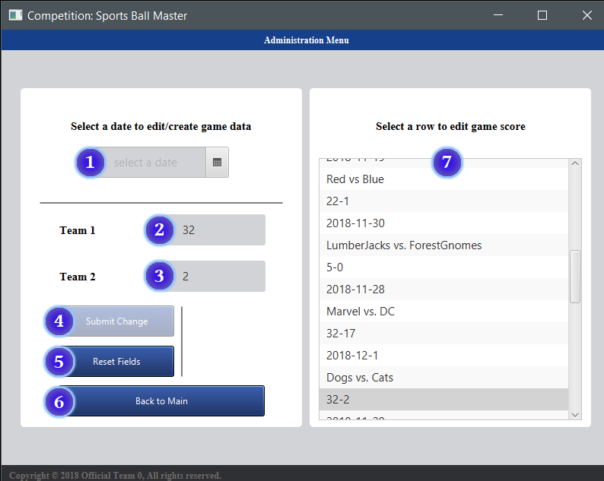

The Admin Screen is divided into two sides. The left window will contain input fields and buttons and the right window contains a list of games’ details.

Clicking on an item in the list on the right will change the input fields and buttons to allow the user to edit the score of a game. The score selected will display in the input fields.

Note: Only the score is editable, although the game and date is clickable, the Submit button will be disabled if the item selected is not a score of a game.

|  |  |
| --- | --- |
| Screen Element | Description |
| 1. Date Picker | This Date Picker is used to select a date to create a game on. |
| 2. Team 1 Score Field | Enter score of the first team of selected game. |
| 3. Team 2 Score Field | Enter score of the second team of selected game. |
| 4. Submit Change Button | Confirm input fields and change score with the values in the input fields. |
| 5. Reset Fields Button | Clears the input fields. |
| 6. Back to Main Button | Take user back to the Main Menu, signing out of the Administrator account. |
| 7. Games List | A list displaying all the games created in the system. |

2.4 Errors and Malfunctions

* There is currently no handle for creating multiple games on one day. Doing so only affects the Calendar Tab. The calendar will only display the latest game entry found with a specific date as it fills each day of the month.
* When signed in as a Fan account, the user should also be able to view their followed team’s wins, losses, ration, and standings. Due to time constraint, these were not implemented into the final program.
* Athlete and Manager users would also have the ability to set a profile picture so that other users would be able to identify them easier. An empty profile picture currently occupies the space allocated for such functionality that the group did not have time to implement into the final program.
* When an admin is creating a game, they are able to provide any name for the two teams to play on the selected date. There is currently no handle to check if those teams entered exist in the league.
* When an admin edits the score to a game, a winner should be selected and the wins and losses of the two teams involved should be adjusted to reflect the updated. This functionality has not been implemented yet, thus all the wins and losses in the database is fixed.

3. File Structure

3.1 Accounts File

|  |  |  |  |
| --- | --- | --- | --- |
| Account Identifier | Username | Password | Account ID |
| First Name | Last Name |  |  |
| Account Type | Team Name |  |  |

Example:

ecun0000 Thor Pass userID=0

Thor Odinson

Athlete Marvel-Comics

When an account is created 3 lines of text are taken by the account in the text file. The first line comes with the account identifier to show that that line contains a username and password and it is given a unique ID to identify people with the same name. The second line contains the accounts name, while the third line contains the account type they are and what team they have joined.

3.2 Athletes File

|  |  |  |
| --- | --- | --- |
| First Name | Last Name | Account ID |
| Team Name | Wins | Losses |

Example:

Thor Odinson userID=0

Marvel-Comics 4 6

Each athlete is dedicated 2 lines of text in the athletes file. The first line contains their full name, and the second line contains the team they are in and how many wins and losses they have participated in.

3.3 Games File

|  |  |  |
| --- | --- | --- |
| Year | Month | Day |
| Team | vs | Team |
| Score | - | Score |

Example:

2018-11-22

Marvel vs DC

22-13

The first line of the games file contains the day that the game was played in yyyy-mm-dd format. There can only be one game per day, if a game is on the same day as another game the game later on the document overwrites it. The second line contains who is playing the game. The last line contains the score for each team that participated in the event.

3.4 Teams File

|  |  |  |
| --- | --- | --- |
| Team | Wins | Losses |
| Manager First Name | Manager Last Name |  |

Example:

Marvel-Comics 13 11

Stan Lee

This file contains a list of all the teams in the league with the team’s wins, losses, and manager’s name. A team is dedicated two lines of text in this file. The first line contains the team’s name followed by its total wins and then total losses. The second line contains the team’s manager’s first and last name.

3.4.1 Team Specific Files

|  |  |
| --- | --- |
| Last Name | First Name |

Example:

Parker, Peter

A file is created for the team created when a manager account is created. This file holds the names of all the athletes in this team’s roster. The format of the contents of the file is an athlete’s last name followed by a comma, and then the athlete’s first name. The name of the file is the team’s name; ex. Marvel-Comics.txt.